**Practical 05 : Estimation and Planning**

It is very crucial to do Agile Estimation at different Levels. This is done for proper planning, management and estimating the total efforts that we are going to use for implementing, testing and delivering the desired product to the Customers in terms of time within the specified deadlines.

With lack of Estimations in Agile Project, there may be no proper planning and management which may end in delivering the undesired product and thereby leaving the customer unsatisfied.

Story point Estimations are done in Agile projects using different techniques like Planning Poker, Bucket System, Affinity Mapping, etc.

Different estimation templates at different levels are used for this purpose like Agile Project Plan Template, Release Plan Template, Sprint Plan Template, RoadMap Template, User Story Template etc.

Stages Of Estimation In Agile Project

**In an Agile Project, estimations are done at 3 levels as mentioned below:**

* **Project/Proposal Level:** Total functional size of the whole application is estimated using Quick Function Point Analysis (QFPA) method when only high level requirements are available.
* **Release Level:** Story points are assigned to the user stories which help in determining the no. of releases planned within a project and the no. of user stories to be taken in a release and sprint.
* **Sprint Level:** Estimated hours are assigned to the tasks of the user stories within a sprint. This is done to ensure the commitment of the development for delivering user stories with in a sprint.

S1, S2,S3,S4,S5,S6 are sprints.

[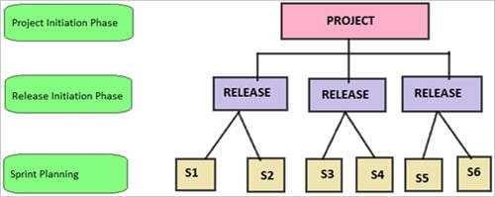](https://cdn.softwaretestinghelp.com/wp-content/qa/uploads/2017/12/Estimations.jpg)

**#1) Proposal or Project Level Estimation**

It is a very high-level estimation for the project. It focuses on the total no of requirements in the Product Backlog item. Function Points is used to estimate the size of the software/project before a detailed description of the functional requirements is documented.

Function points are the universally accepted way to calculate the size of the software. It focuses on the functionalities found in the software projects. A function point is a metric which converts the requirements or user stories into a number.

During the initial stages of the project, it is recommended to adopt Quick Function Point Analysis (QFPA) method.

Quick Function Point Analysis method is a unique approach for estimating FP when only high-level requirements are available.

**How to calculate Total Functional size?**

* Understand all the functionalities of an application with the help of domain experts.
* Identify and list all the possible functionalities of an application.
* Data storage functions are classified into Internal Logic Files (data stored internally within the application) and External Interface Files (data used for reference purpose only).
* Transaction functions are classified into External Inputs (data coming from external sources to application), External Outputs (derived data goes from application to outside) and External Inquiries (data retrieved from one or more External Inputs and External outputs).
* Calculate FP size for each function by calculating its average complexity.
* Sum up FP size of all the functions, to get the Total Functional Size of the application.
* At least two persons with expertise in FP analysis, should calculate independently, match results and resolve the differences.

[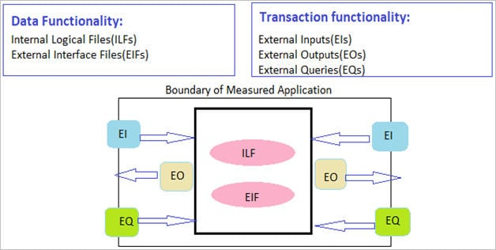](https://cdn.softwaretestinghelp.com/wp-content/qa/uploads/2017/12/total-functional-size.jpg)

**Example for Project-Level Estimation:**

**Below is the list of requirements for a project, as in Product Backlog:**

* A user should be able to login to the website by providing the username and password.
* Post successful login, a user should be taken to the main page with right and left panes defined.
* A user should have an option to logout from the Application.
* A valid user has the option of changing the password by providing current credentials.

The team uses a Quick FP estimation to estimate the project size.

**Following is the analysis done:**

* Data storage function here is storing the User Credentials to log in and change the password.
* Since the credentials are stored within application boundary, it is stored in ILFs (Internal Logical Files).
* **The Transaction functions include:**
  + User login and display of the main page.
  + User logout and display of logout screen.
  + Ability to change the password.

**Below are the steps executed to estimate the Project size using Quick Function Point Analysis:**

**STEP #1: List down all the Data Functions**

| **Data Function** | **Type** | **UFP** |
| --- | --- | --- |
| User Credential Information | ILF | 10 |

UFP (Unadjusted Function Point) is taken from Caper Jones Table.

**STEP #2: List down all the Transaction Functions**

| **Transaction Function** | **Type** | **UFP** |
| --- | --- | --- |
| Login and display main page | EQ | 4 |
| Logout and display logout screen | EQ | 4 |
| Change Password | EI | 4 |

UFP (Unadjusted Function Point) is taken from Caper Jones Table.

**STEP #3: Deriving the estimated project size in Function Points**

UFP = Data FP + Transaction FP

UFP=10 + 12 = 22 UFP

FP = UFP * VFP = 22 * 1 = 22 FP (Assuming VFP (Value Adjustment Factor=1)

Productivity = 16 FP/month (Normal Standard)

Effort = FP/Productivity = 22/16-person month = 1.37 person month

**#2) Release Level Estimation**

Release level estimations are done during the Release planning. It is the next activity after Project level estimation. The prioritized requirements are taken from the Product Backlog which is in the form of User Stories.

The user stories are estimated in terms of story points during the Release planning which focuses on estimating the size of the software to be delivered for that release. In this way, no of releases and total no of story points in each release is planned.

A story point basically represents the relative effort required to implement a feature or the functionality, when compared to the other features. It is basically for sizing the Product Backlog items.

**Story point estimation is done on the basis of:**

* The complexity of the feature to be implemented.
* Experience and technical skills of all the members.

S1,S2,S3,S4,S5 are sprints.

[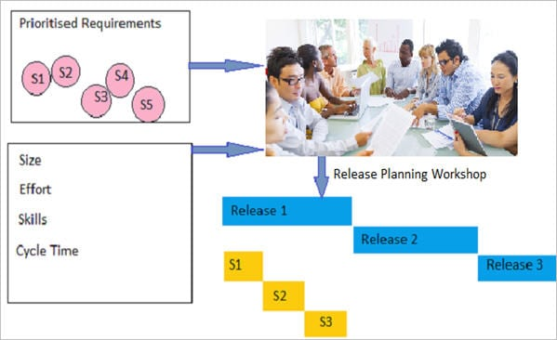](https://cdn.softwaretestinghelp.com/wp-content/qa/uploads/2017/12/RELEASE-LEVEL-ESTIMATION.jpg)

**Steps for assigning story points to a user story:**

* All the team members gather around a table going through the user stories present in the Sprint Backlog.
* Meaning of one story point and corresponding effort is decided.
* One of the team members reads out a user story and then asks the team members to assign the relative story points.
* If there is a significant difference between the story points assigned by the team members then they give an explanation for story points that they have assigned, thereby reaching a consensus at the end.
* The process is repeated 3-4 times until there is no major difference between the estimations given by the team members.
* Sizing of stories helps in determining how many stories will be taken within a sprint and release.

**Example for Release Level Estimation:**

This involves creating a prioritized list of User Stories called Product Backlog. Product Owner creates Product Backlog and provide business value for each of the item listed in it.

| **User Story ID** | **User Story** | **Acceptance Criteria** |
| --- | --- | --- |
| US-01 | As a User, I want to have a login screen where I can log into the application using my credentials: username and password | • A valid user should be able to see login screen and provide credentials. • After login, user credentials should be checked for authenticity. |
| US-02 | As a User, after successful login, I want to see the main page with header, left, right panes and logout option. | • A valid user should be able to see Home screen on successful login. • User should be able to see header, left and right panes along with logout option. |
| US-03 | As a User, I should be able to logout successfully on clicking logout option and after logout, should see the logout screen. | • While on main page, user should be able to click on ‘logout’ button. • User should be successfully logged out on clicking ‘logout’.  • User should see logout screen after logout. • User should be able to login again after logout. |

**We can use the below methods for Story Points Estimations:**

* **Numeric Sizing:** 1 through 10
* **T-Shirt Sizing:** Each requirement classified as Extra Small (XS), Small (S), Medium (M), Large (L), Extra Large (XL).
* **Fibonacci Series:** Estimation done through Fibonacci Sequence (1,2,3,5,8,13,21,34,….)

**Estimation of the above user stories through the Fibonacci sequence:**

| **US ID** | **Estimated Story Points** |
| --- | --- |
| US-01 | 8 |
| US-02 | 3 |
| US-03 | 4 |

**#3) Sprint Level Estimation**

Sprint level estimations are done during Sprint Planning. Highest priority product backlog items are taken and divided into different tasks like Detailing, Design, Analysis, Development, Create Test Cases, Execute Test Cases, User Acceptance Testing etc.

Tasks are estimated in terms of estimated hours i.e. the time required to complete that task for a corresponding user story. The Bottom-Up Approach is used for the Task estimations where the business requirements are broken down into low-level activities and each activity is assigned estimated hours.

The purpose of the estimations is to know how many user stories, the development team can commit to a Sprint. The development must be comfortable with the commitment and the Product Owners must be confident that the team will deliver on the commitment.

[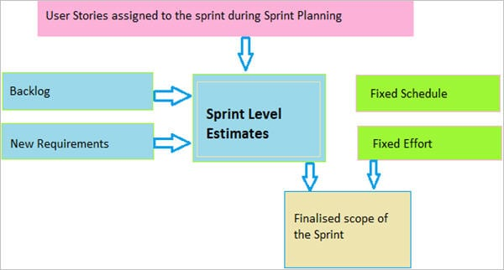](https://cdn.softwaretestinghelp.com/wp-content/qa/uploads/2017/12/SPRINT-LEVEL-ESTIMATION.jpg)

S**teps for assigning estimated hours to the tasks:**

* Team members pick up the user stories.Then, they are asked to estimate the actual effort, in terms of hours or days, for the tasks corresponding to the user story.
* If there is a disagreement in these estimates among the team members, then they discuss it and come to a consensus.
* If any task is of more than six hours, it is split into smaller tasks.
* If there are two or more tasks with estimated hours less than two, then they are combined to form a new task.

**Example for Sprint Level Estimation:**

**There are two parts of Sprint Planning meeting:**

* **First Part:** Focus is on clarifying the requirements for User Stories, selected from the Product Backlog.
* **Second Part:** Focus is on breaking the requirements into tasks and estimating the hours required to complete them. All the tasks necessary to make the Product Backlog item deliverable, should be included. The tasks should be small. Ideally, a task effort should not be of more than six hours.

| **US ID** | **Task ID** | **Task Description** | **Task Activity** | **Assigned To** | **Priority (1=low to 9=highest)** | **Status** | **Estimated Effort Hours** |
| --- | --- | --- | --- | --- | --- | --- | --- |
| US-01 | TAS-01 | Designing Login Page | System Design | Amit | 9 | Completed | 3 |
| US-01 | TAS-02 | Unit Test Plan and System Test Plan | System Test Plan | Puja | 8 | Completed | 4 |
| US-01 | TAS-03 | Develop Login Page | Build | Development Team | 7 | Completed | 5 |
| US-01 | TAS-04 | Login page user validation | Build | Development Team | 6 | In Progress | 6 |
| US-02 | TAS-05 | System test success and failure scenarios of login page | System Test | QA Team Offshore | 5 | Not Started | 4 |
| US-02 | TAS-06 | Integration testing of Login page | Integration testing | QA Team Offshore | 4 | Not Started | 3 |
| US-02 | TAS-07 | Acceptance test by Internal customer | Acceptance testing | QA Team Onsite | 8 | Not Started | 6 |

<https://www.softwaretestinghelp.com/planning-poker-scrum-poker-cards-agile-estimation/>

Now imagine that the Product Owner gives you this User story “As a customer, I want to download my account statement so that I can view all my transactions done for a specific period”.

**With the following Acceptance Criteria:**

* Considering that I am on the Download Historical Statement Page, I should select the period for which I want to download the statement.
* Considering that I am on the Download Historical Statement Page, I should select the account for which I want to download the statement.
* Considering that I am on the Download Historical Statement Page, I should not be allowed to download the statement for future ‘To’ date.
* Considering that I am on the Download Historical Statement Page, I should not be allowed to select ‘From’ date 10 years beyond in the past.
* Considering that I download my statement, I should be able to view the downloaded file.
* Considering that I am on the Download Historical Statement Page, I should be able to download my statement in doc, excel and pdf formats.

**If you go through this acceptance, there are 3 things missing here:**

* Name and format of the file name that will be downloaded.
* What information (Column names) is to be displayed in the file.
* The options list to select what kind of a transaction the customer wants i.e. only debits or only credits or both.

Such cases may happen once in a while, however still study well about each acceptance criteria and try to visualize it with reference to the user story. The more you study deeply about the conditions and business rules the more will be your knowledge about the feature.

Bugs found in the initial stage cost nothing compared to what it may cost in the ‘testing’ stage.